University of Central Florida
Department of Electrical Engineering & Computer Science
COP 3402: System Software
Spring 2013

Homework #4 (PL/0 Compiler)

Due Monday, April 15, 2013 by 11:59 p.m.

Objective:
In this assignment, you must extend the functionality of Assignment 3 to include the additional grammatical constructs highlighted in yellow in Appendix B. Also you have to remove the scanner (HW2) and instead use FLEX to scan an input file and generate the tokens to be passed into the parser/code generator.

Example of a program written in PL/0:
int x, w;
begin
x:= 4;
read w;
if w > x then
w:= w + 1
else
w:= x;
write w;
end.

Component Descriptions:
The scanner performs lexical analysis on a given input. For HW4 your scanner will be created using FLEX, a lexical analyzer generator. Instead of tediously coding a lengthy C source file to describe how the scanner should function, Flex allows you to use a variant of regular expressions to define each token type and to associate the actions (written in C) for the scanner to take when each pattern (token type) is matched. The Flex file you specify this information in (which has a .l extension – that's a lowercase "L") is then sent to Flex.exe, which in turn expands it to that lengthy C source file on its own, which is named lex.yy.c. This C file is then compiled and then its executable is run with the input to be scanned. For HW4, you will print the output of this execution to a file (referred to as the "Flex output file") and it will be used as input to your parser/code generator from HW3. For more information and an example of how to use Flex for this assignment, please see Appendices F and G.

The compiler driver is a program that manages the parts of the compiler. It must load the Flex output file generated by your scanner, and then it must handle the Parser (HW3) / Intermediate Code Generator (HW3) and the Virtual Machine (HW1).

The compiler must read a program written in PL/0 and generate code for the Virtual Machine (VM) you implemented in HW1. Your compiler must neither parse nor generate code for programming constructs that are not in the grammar described below.

Submission Instructions:
1.- Submit via WebCourses:
- Source code of the Flex file.
- Source code of the PL/0 compiler.
- A text file with instructions on how to use your program entitled readme.txt.
- A text file composed of the input file to your Scanner and the output of your Parser to demonstrate a correctly formed PL/0 program. The Parser output should indicate the program is syntactically correct. Following the statement that the program is syntactically correct, the text file should contain the generated code from your intermediate code generator and the stack output from your Virtual Machine running your code.
- A text file (or screenshots) composed of the input file to your Scanner and the output of your Parser to demonstrate all possible errors. This may require many runs and the Parser output should indicate which error is being identified.
- All files should be compressed into a single .zip format.
- Late assignments will not be accepted.

Recommendations:
- Between installing Flex and the learning curve associated with using it for the first time, you will almost certainly experience problems. It is highly recommended to start this project early.

- The Flex manual (http://flex.sourceforge.net/manual/) is your friend and you should expect to use it. However, be advised that this project does not use Flex as many other programs do. The primary difference is that we will not "return" anything to a parser; instead, we will print that information to a file using printf/fprintf. This means not all of the information that is in the manual is applicable to how Flex will function for this project – for example, we will not be using yylex() or values like yylval.
Appendix A:

Traces of Execution:

Example 1, if the input is:

int x, y;
begin
x := y + 56;
end.

The output should look like:

1.- A print out of the token (internal representation) file:

29 2 x 17 2 y 18 21 2 x 20 2 y 4 3 56 18 22 19

And it’s symbolic representation:

intsym identsym x commasym identsym y semicolonsym beginsym identsym x becomessym identsym y plussym numbersym 56 semicolonsym endsym periodsym

2.- Print out the message “ No errors, program is syntactically correct”

3.- Print out the generated code

4.- Run the program on the VM virtual machine (HW1)

Example 2, if the input is:

int x, y;
begin
x := y + 56;
end ← ( notice period expected after the “end” reserved word)

The output should look like:

1.- A print out of the token (internal representation) file:

29 2 x 17 2 y 18 21 2 x 20 2 y 4 3 56 18 22

And its symbolic representation:

intsym identsym x commasym identsym y semicolonsym beginsym identsym x becomessym identsym y plussym numbersym 56 semicolonsym endsym

2.- Print the message “Error number xxx, period expected”

int x, y;
begin
x := y + 56;
end
***** Error number xxx, period expected

Example 3: Use this example (recursive program) to test your compiler:
int f, n;
procedure fact;
int ans1;
begin
ans1:=n;
n:= n-1;
if n = 0 then f := 1;
if n > 0 then call fact;
f:=f*ans1;
end;

begin
n:=3;
call fact;
write f;
end.

Example 4:Use this example (nested procedures program) to test your compiler:

int x,y,z,v,w;
procedure a;
int x,y,u,v;
procedure b;
int y,z,v;
procedure c;
int y,z;
begin
z:=1;
x:=y+z+w
end;
begin
y:=x+u+w;
call c
end;
begin
z:=2;
u:=z+w;
call b
end;
begin
x:=1; y:=2; z:=3; v:=4; w:=5;
x:=v+w;
write z;
call a;
end.

Appendix B:

EBNF of PL/0:

program ::= block "." .
block ::= const-declaration var-declaration procedure-declaration statement.
const-declaration ::= ["const" ident "=" number {"," ident "=" number} ";"].
var-declaration ::= [ "int "ident {"," ident} ";"].
procedure-declaration ::= { "procedure" ident ";" block ";" }
statement ::= [ ident ":=" expression
| "call" ident
| "begin" statement { ";" statement } "end"
| "if" condition "then" statement ["else" statement]
| "while" condition "do" statement
| "read" ident
| "write" ident
| e ] .
condition ::= "odd" expression
| expression rel-op expression.
rel-op ::= "="|"<>"|"<"|"<="|">"|">=".
expression ::= [ "+"|"-"] term { ("+"|"-") term}.
term ::= factor {("*"|"/") factor}.
factor ::= ident | number | "(" expression ")".
number ::= digit {digit}.
ident ::= letter {letter | digit}.
digit ::= "0" | "1" | "2" | "3" | "4" | "5" | "6" | "7" | "8" | "9".
letter ::= "a" | "b" | … | "y" | "z" | "A" | "B" | ... | "Y" | "Z".

Based on Wirth’s definition for EBNF we have the following rule:
[ ] means an optional item.
{ } means repeat 0 or more times.
Terminal symbols are enclosed in quote marks.
A period is used to indicate the end of the definition of a syntactic class.

Note: Implementing procedure calls and IF-THEN_ELSE is mandatory.

Appendix C:

Error messages for the tiny PL/0 Parser:
- Use = instead of :=.
- = must be followed by a number.
- Identifier must be followed by =.
- const, int, procedure must be followed by identifier.
- Semicolon or comma missing.
- Incorrect symbol after procedure declaration.
- Statement expected.
- Incorrect symbol after statement part in block.
- Period expected.
- Semicolon between statements missing.
- Undeclared identifier.
- Assignment to constant or procedure is not allowed.
- Assignment operator expected.
- call must be followed by an identifier.
- Call of a constant or variable is meaningless.
- then expected.
- Semicolon or } expected.
- do expected.
- Incorrect symbol following statement.
- Relational operator expected.
- Expression must not contain a procedure identifier.
- Right parenthesis missing.
- The preceding factor cannot begin with this symbol.
- An expression cannot begin with this symbol.
- This number is too large.

Note: Not all of these error messages may be used, and you may choose to create some error messages of your own to more accurately represent certain situations.

Appendix D:

Recursive Descent Parser for a PL/0 like programming language in pseudo code:

As follows you will find the pseudo code for a PL/0 like parser. This pseudo code will help you out to develop your parser and intermediate code generator for tiny PL/0:

procedure PROGRAM;
begin
GET(TOKEN);
BLOCK;
if TOKEN != "periodsym" then ERROR
end;

procedure BLOCK;
begin
if TOKEN = "constsym" then begin
repeat
GET(TOKEN);
if TOKEN != "identsym" then ERROR;
GET(TOKEN);
if TOKEN != "eqsym" then ERROR;
GET(TOKEN);
if TOKEN != NUMBER then ERROR;
GET(TOKEN)
until TOKEN != "commasym";
if TOKEN != "semicolomsym" then ERROR;
GET(TOKEN)
end;
if TOKEN = "var" then begin
repeat
GET(TOKEN);
if TOKEN != "identsym" then ERROR;
GET(TOKEN)
until TOKEN != "commasym";
if TOKEN != "semicolomsym" then ERROR;
GET(TOKEN)
end;
while TOKEN = "procsym" do begin
GET(TOKEN);
if TOKEN != “identsym” then ERROR;
GET(TOKEN);
if TOKEN != "semicolomsym" then ERROR;
GET(TOKEN);
BLOCK;
if TOKEN != "semicolomsym" then ERROR;
GET(TOKEN)
end;
STATEMENT
end;

procedure STATEMENT;
begin
if TOKEN = "identsym" then begin
GET(TOKEN);
if TOKEN != "becomessym" then ERROR;
GET(TOKEN);
EXPRESSION
end
else if TOKEN = "callsym" then begin
GET(TOKEN);
if TOKEN != "identsym" then ERROR;
GET(TOKEN)
end
else if TOKEN = "beginsym" then begin
GET TOKEN;
STATEMENT;
while TOKEN = "semicolomsym" do begin
GET(TOKEN);
STATEMENT
end;
if TOKEN != "endsym" then ERROR;

GET(TOKEN)
end
else if TOKEN = "ifsym" then begin
GET(TOKEN);
CONDITION;
if TOKEN != "thensym" then ERROR;
GET(TOKEN);
STATEMENT
end
else if TOKEN = "whilesym" then begin
GET(TOKEN);
CONDITION;
if TOKEN != "dosym" then ERROR;
GET(TOKEN);
STATEMENT
end
end;

procedure CONDITION;
begin
if TOKEN = "oddsym" then begin
GET(TOKEN);
EXPRESSION
else begin
EXPRESSION;
if TOKEN != RELATION then ERROR;
GET(TOKEN);
EXPRESSION
end
end;

procedure EXPRESSION;
begin
if TOKEN = "plussym"or "minussym" then GET(TOKEN);
TERM;
while TOKEN = "plussym" or "slashsym" do begin
GET(TOKEN);
TERM
end
end;

procedure TERM;
begin
FACTOR;
while TOKEN = "multsym" or "slashsym" do begin
GET(TOKEN);
FACTOR
end
end;

procedure FACTOR;
begin
if TOKEN = "identsym then
GET(TOKEN)
else if TOKEN = NUMBER then
GET(TOKEN)
else if TOKEN = "(" then begin
GET(TOKEN);
EXPRESSION;
if TOKEN != ")" then ERROR;
GET(TOKEN)
end
else ERROR
end;
Appendix E:

Symbol Table

Recommended data structure for the symbol.

typedef struct
{
int kind; // const = 1, var = 2, proc = 3
char name[10]; // name up to 11 chars
int val; // number (ASCII value)
int level; // L level
int addr; // M address
} symbol;

symbol_table[MAX_SYMBOL_TABLE_SIZE];

For constants, you must store kind, name and value.
For variables, you must store kind, name, L and M.
For procedures, you must store kind, name, L and M.

Appendix F:

Flex Information and Examples:

What is Flex?

Flex is a tool that generates a program for performing lexical analysis (i.e., scanning) on input files. It is most often used alongside a parser generating tool, the most common of which are Bison and Yacc, but for this assignment, you will be using it to provide input to the parser you created in HW3.

The Flex manual (which is very helpful!) is located at http://flex.sourceforge.net/manual/

How to Download/Install:

- Windows: Go to http://flex.sourceforge.net/ for source, or http://gnuwin32.sourceforge.net/packages/flex.htm for Windows executable

- Eustis: Flex version 2.5.35 is already installed on the server.

- Linux: You will most likely need to install the package for Flex (e.g., by the command line "sudo yum install flex"); however, the package name can vary depending on your Linux distribution, so check Google for how to install. For example, if you search for "flex fedora" you will learn that the package name is "flex".

How to use it:

- Download/install Flex (see links above).
- Write a Flex file that contains all info pertinent to the lexical analysis for your grammar.
- Run Flex, passing your Flex file into it as an argument.
- Compile the newly-generated C source file, lex.yy.c
- Run the resulting executable with the input file (the file should either be passed in as an argument or requested from the user during runtime; either way, the code to handle this should be placed in your Flex file).

How it works:

The Flex file you write (filename ending with .l) provides the lexical analysis information for the grammar in shorthand. It consists of any number of Flex regular expressions (slightly different than the RegEx you are familiar with; see Appendix G) paired with actions written in C for the scanner to take when that pattern is found in the input file. When you pass the Flex file into Flex, Flex takes the information you have provided and expands it into a lengthy C source file (lex.yy.c), which can then be compiled and run with some input file, just like the scanner you wrote in HW2.
Flex Example:
The example below is for a grammar that is used to perform simple calculations on integers. The scanner for this example recognizes the tokens in the grammar and prints them to the screen. Although this grammar and its token types are different from what you must implement, it should not be too difficult to extend this example to your current project, especially with the help of the manual.

FLEX FILE (calc.l):
/* Properly formatted code/comments in this section will be prepended to lex.yy.c */
%{
#include <stdlib.h>
%}

/* Macros */
I [iI]
N [nN]
T [tT]

digit [0-9]
integer {digit}+

%%

/* Reserved Word (not case sensitive) */
{I}{N}{T} { printf("intsym "); }

/* Whitespace (currently, spaces and tabs only) */
[ \t]+ { }

/* Number */
{integer} { printf("number %s ", yytext); }

/* Special Symbols */
"+" { printf("plus "); }
"-" { printf("minus "); }
"*" { printf("times "); }
"/" { printf("divide "); }
"(" { printf("lparen "); }
")" { printf("rparen "); }
\n { printf("\n\n"); }
. { printf("INVALID(%s) ", yytext); }

%%

/* Properly formatted code/comments in this section are appended to lex.yy.c */

/* If called, allows for scanning of another file */
int yywrap()
{
return 1;
}

/* Main function for Flex file */
int main(int argc, char* argv[])
{
if (argc > 1) yyin = fopen(argv[1], "r");
else yyin = stdin;
yylex();
return 1;
}

INPUT FILE (input.txt):
int 5
InT 09479;
(5*5)+12
3 $/ 15 -1

COMMAND LINE ARGUMENTS:
flex.exe calc.l
gcc -oCalc lex.yy.c
Calc input.txt

FLEX OUTPUT FILE:
intsym number 5

intsym number 09479 INVALID(;)

lparen number 5 times number 5 rparen plus number 12

number 3 INVALID($) divide number 15 minus number 1

Then, this output file would be sent to the parser for parsing. The final output of the parser should still resemble the output of the examples in Appendix A.

Note: Error handling should be taken into account just as in the previous assignments; however you handled errors (such as invalid symbols) previously, you should do so similarly in HW4.

THINGS TO NOTE

- Your scanner should print the tokens to a file, NOT to the screen (unless you wish to do both)

- The string of tokens in the Flex output file should be printed in the same way as you've
printed them in previous assignments (i.e. just like they are shown in Appendix A)

- It is essential to follow Flex guidelines for alignment of code and comments. See the manual.

- You can add additional code and functions to the Flex file as needed. Things that you would normally add at the beginning of a C source file – such as function declarations, global variables, preprocessor directives, etc. – should be placed in the first section of the Flex file, before the first "%%". Extra functions and/or other code that need not be placed at the very top of C source files should be placed in the last section of the Flex file, below the last "%%". Code in these sections, if properly formatted according to Flex standards, will be copied verbatim into lex.yy.c.

Appendix G:

Flex regular expressions

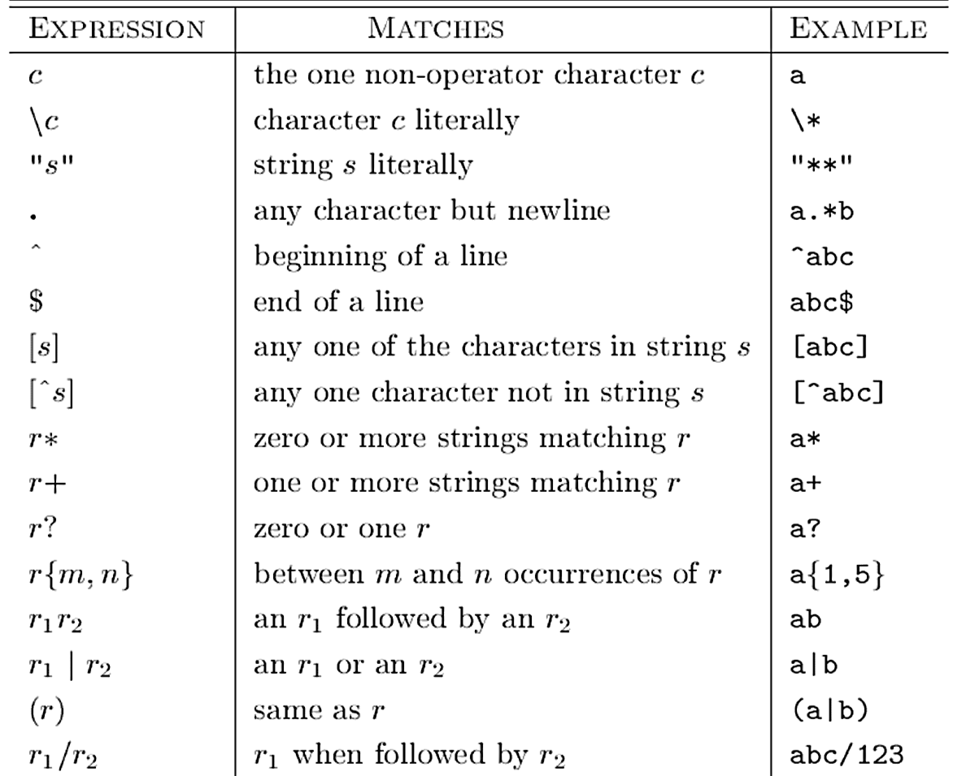
The regular expressions used to specify token patterns in Flex are different from the RegEx regular expressions that you may be familiar with. Below is a chart of the Flex regular expressions for you to use when writing your Flex file.

